**CE Web Page Creation for Content**

To create a CE web page from a content file, log into CE site <http://www.jcubictech.com> with an admin account, hover over the *Admin* menu and then select *Create Web Page*. The following screen appears.

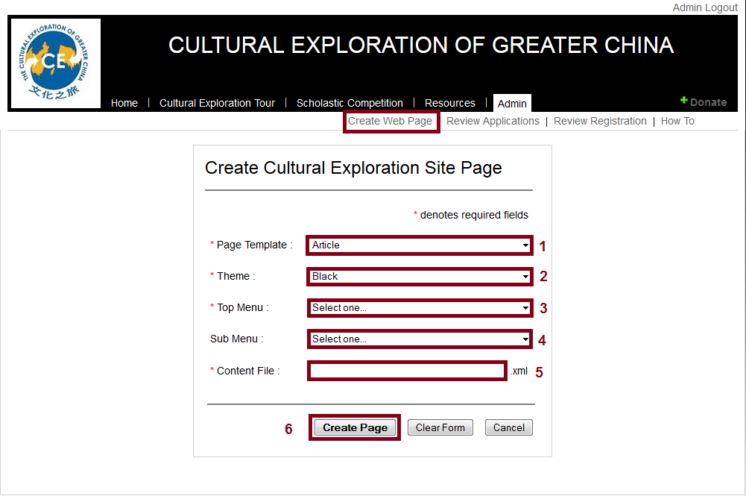

Explanation:

1. Select a content template

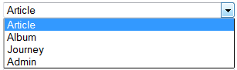

1. Select a theme

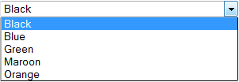

1. Select a top menu

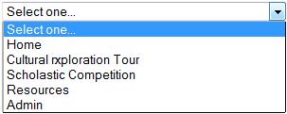

1. Select a 2nd level menu

2nd level menu is a context sensitive to the first level menu selection. For example, if the top menu selection is *Cultural Exploration Tour*, the 2nd level menu will show the following:

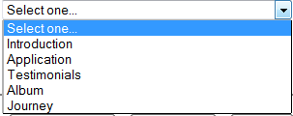

If the top menu select is *Scholastic Competition*, the 2nd level menu will show:

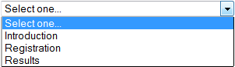

1. Enter a content filename

The name is your content file.

1. Create the web page

Click the button will create a web page for the content in the ***/public/top-menu/submenu*** folder.

1. Move the web page if needed

If you need the web page to reside in different folder, you can move it after the web page is created.